5-2 Activity: Packet Tracer

Blake Merry
Southern New Hampshire University
CYB-210 Programming Language
Prof. Jamilah Telon
April 6, 2026

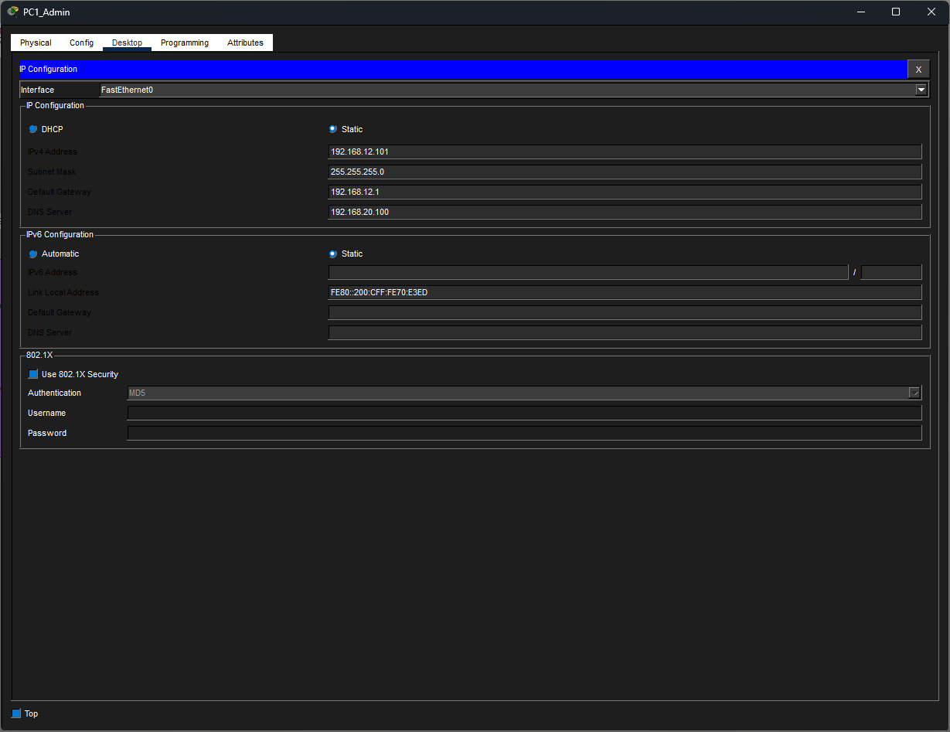
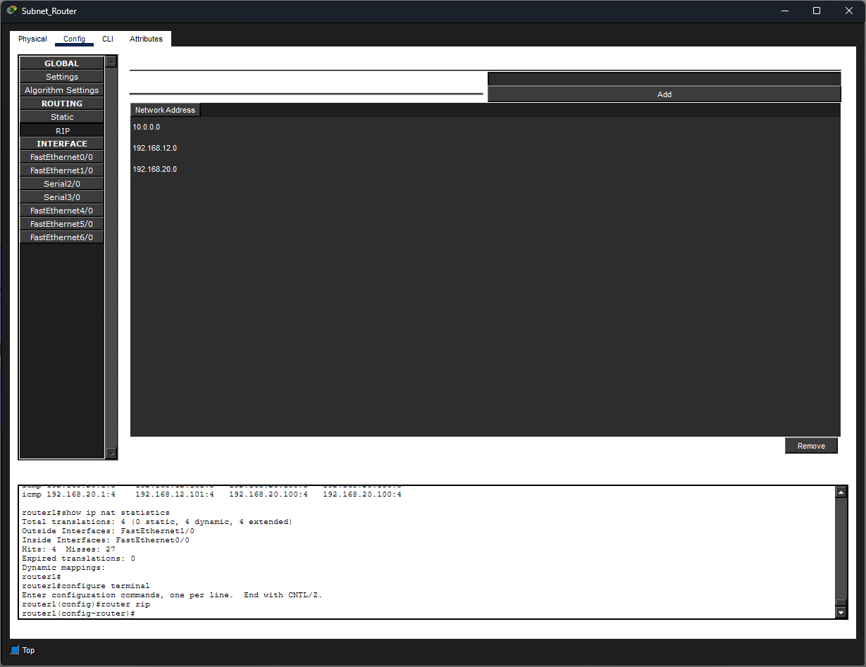
Configure RIP: Executed the commands…
conf t, router rip, no network 192.168.6.0, no network 192.168.9.0, network 10.0.0.0, network 192.168.12.0, network 192.168.20.0, end
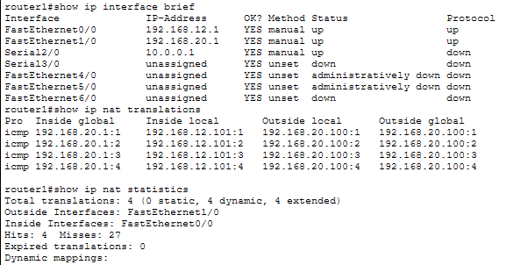
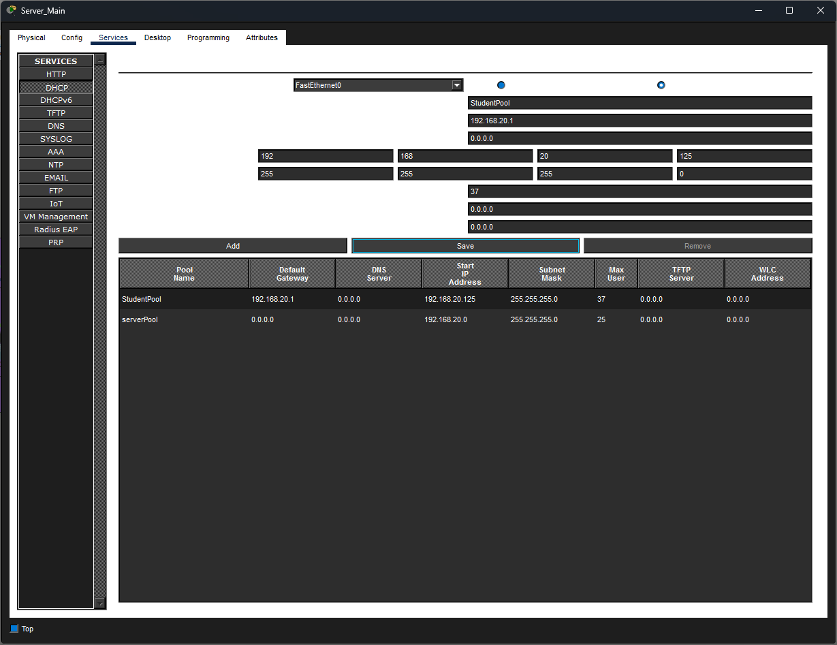
Added StudentPool configured per specifications.
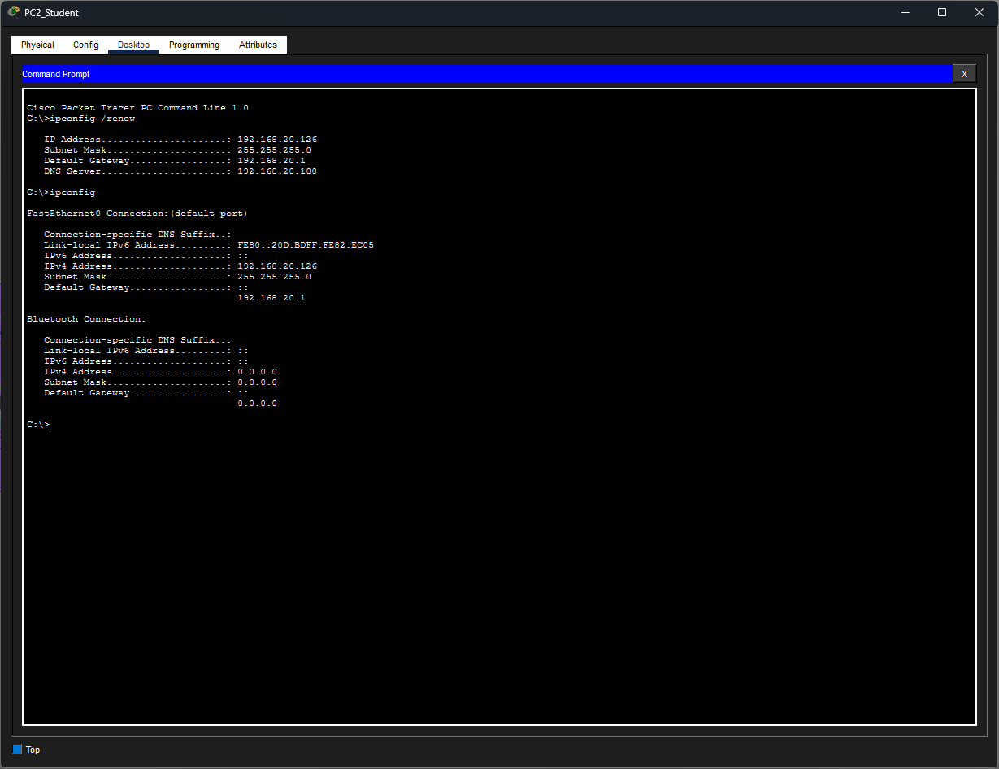
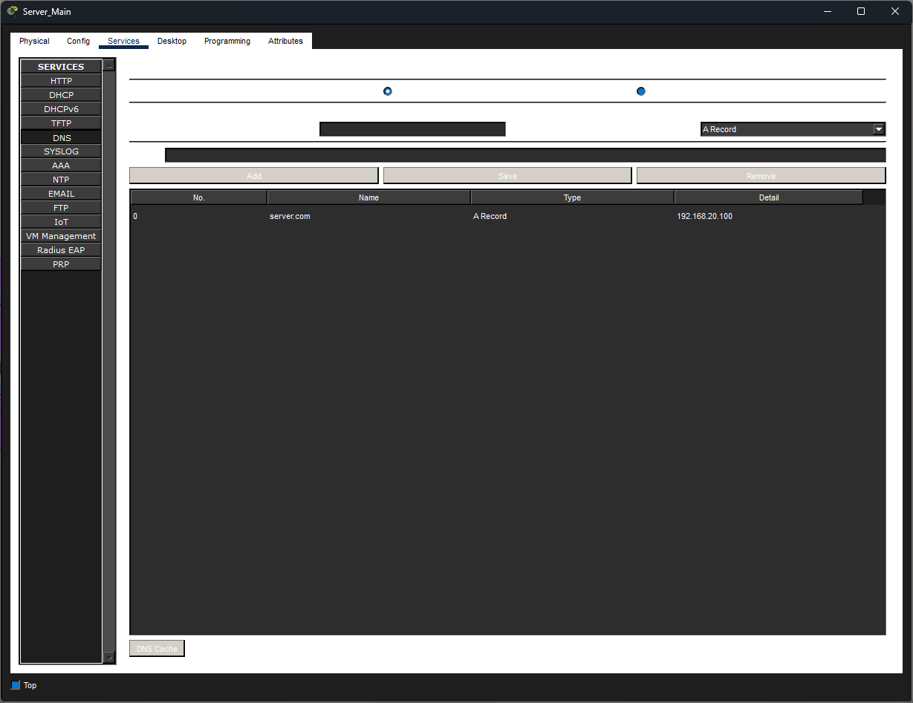
Saved the existing A Record with the updated server IP.
